**Lab Tasks**

**By**

**FARWA RASHID (45945)**

**Subject**: Operating System

**( LAB 02 )**

**Date**: 3/9/2024

**BSCS SEMESTER – 5**

**RIPHAH INTERNATIONAL UNIVERSITY**

**ISLAMABAD**

**Task 01:** To begin, you need to set up a structured directory layout in your home directory. Start by creating two directories named OS_Course and OS_Lab. These directories will serve as the main folders for organizing your OS Lab tasks. After creating these directories, switch to the OS_Lab directory. Within OS_Lab, create three more directories named LAB_Class_Task, LAB_Activities, and Lab_Practice. Each of these directories will help you categorize different aspects of your lab work. Once you have created these directories, go into the Lab_Practice directory and create a file named example.cpp.

**Solution:**

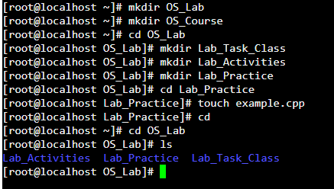



**Explanation:**

* **mkdir OS_Lab ,mkdir OS_Course**

(creating two directories named OS_Course and OS_Lab )

* **cd OS_Lab**

(switch to the OS_Lab directory.)

* **mkdir Lab_Task_Class , mkdir Lab_Activities , mkdir Lab_Practice**

(Within OS_Lab, create three more directories named LAB_Class_Task, LAB_Activities, and Lab_Practice.)

* **cd_Lab_Practice , touch example.cpp**

(go into the Lab_Practice directory and create a file named example.cpp. )

* **cd OS_Lab**

( move back to your home directory )

**Task 02:** Finally, you need to understand the concepts of absolute and relative paths. Explain the difference between these two types of paths and provide an example of each. This will help you navigate directories more effectively. If you are currently in the Lab_Practice directory, describe the relative path to access the **LAB_Activities** directory. This will test your understanding of how to move between directories using relative paths.

**Solution:**

**Absolute Path:**

An absolute path is the full path to a file or directory from the root directory.

**Relative Path:**

A relative path specifies a file or directory location in relation to the current working directory.



**Task 03:**

Imagine you’re working on your computer when you suddenly need to turn it off quickly. You press and hold the power button until the computer shuts down completely. After an hour, you turn the computer back on, and it quickly shows the login screen or desktop.

Why does your computer start up smoothly and quickly after being turned off? Describe the process that happens between powering off the computer and seeing the login or desktop screen. What steps does the computer go through to get everything ready in a short amount of time?

**Solution:**

* When the computer is power on, the first thing that kicks in is the BIOS (Basic Input/Output System). It is a small program stored on a chip on computer motherboard. The BIOS checks that all the important hardware (like the CPU, RAM, and hard drive) is working properly.
* The BIOS runs a quick series of checks to make sure everything is in good state. This process is fast.
* After it checks, the BIOS looks for the boot device usually hard drive or SSD. It then loads a small program called the bootloader from device. The bootloader’s job is to find and load the operating system files.
* The bootloader starts loading the operating system into the RAM. This includes the kernel. The operating system then loads up all the needed drivers that allow your computer to talk to the hardware, like the keyboard, mouse, and display.
* The operating system also runs any applications that are set to run when computer boots up. Once everything is ok place then login screen or desktop will be open.